**1.** Write a Python program to find those numbers which are divisible by 7 and multiple of 5, between 1500 and 2700 (both included)

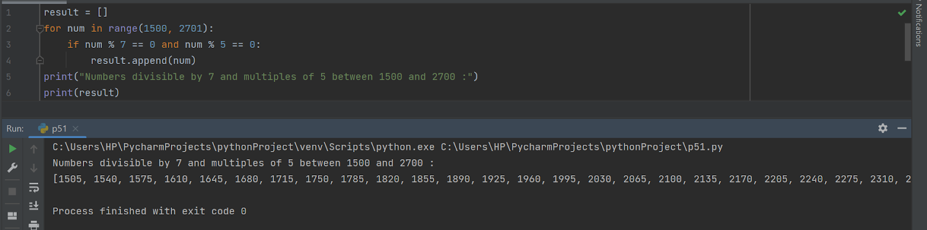

**2.** Write a Python program that prints all the numbers from 0 to 6 except 3 and 6.

Note : Use 'continue' statement.

Expected Output : 0 1 2 4 5

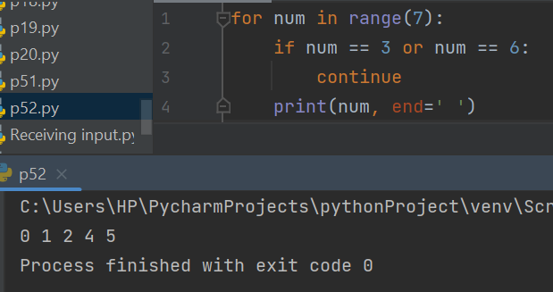

**3.** Write a Python program which iterates the integers from 1 to 50. For multiples of three print "Fizz" instead of the number and for the multiples of five print "Buzz". For numbers which are multiples of both three and five print "FizzBuzz".

*Sample Output* :

fizzbuzz

1

2

fizz

4

Buzz

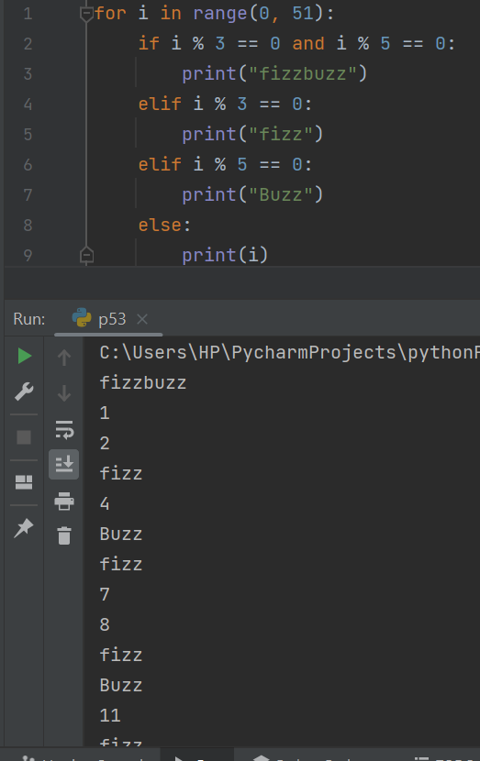

**4.** Write a Python program to check a triangle is equilateral, isosceles or scalene.

Note :

An equilateral triangle is a triangle in which all three sides are equal.

A scalene triangle is a triangle that has three unequal sides.

An isosceles triangle is a triangle with two equal sides.

*Expected Output:*

Input lengths of the triangle sides:

x: 6

y: 8

z: 12

Scalene triangle

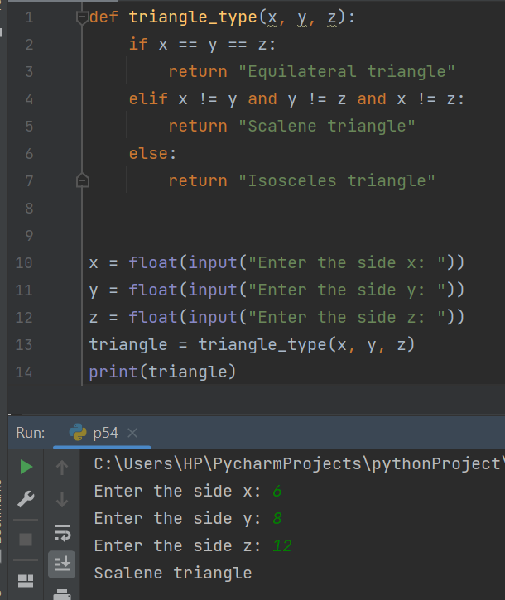

**5.** Write a Python program to calculate the sum and average of n integer numbers (input from the user). Input 0 to finish

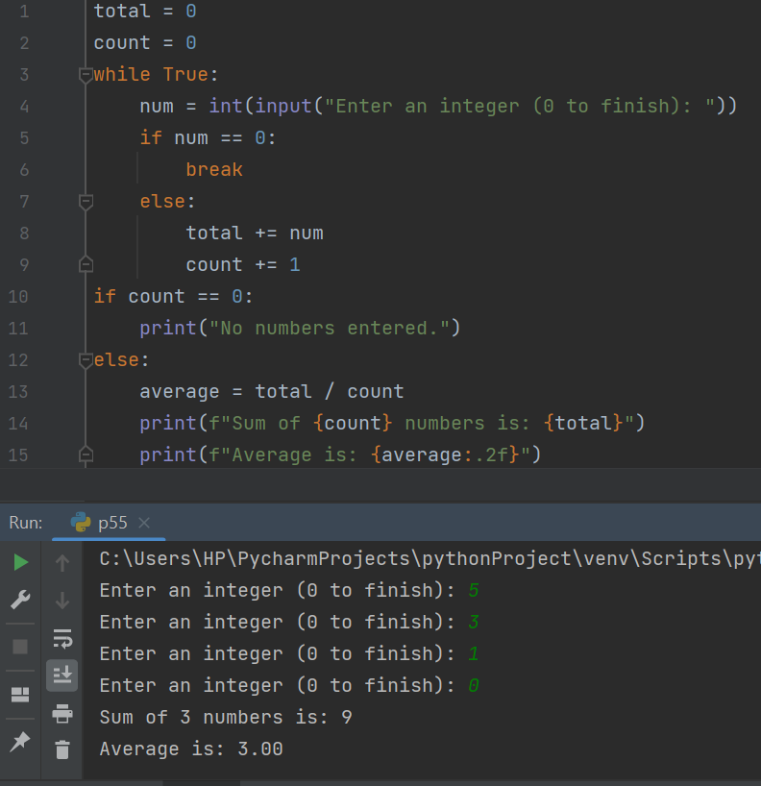

**6.** Write a Python program to construct the following pattern, using a nested loop number.

1

22

333

4444

55555

666666

7777777

88888888

999999999

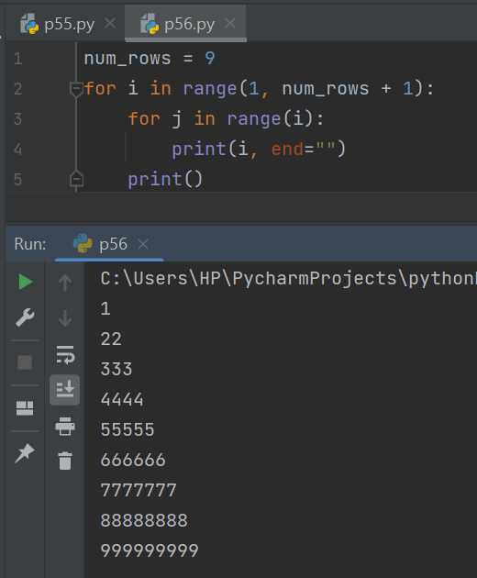

**7.** Write a Python program that counts the number of elements within a list that are greater than 30.

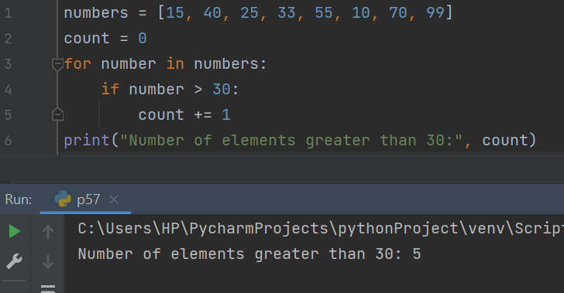

**8. Take values of length and breadth of a rectangle from user and check if it is square or not.**

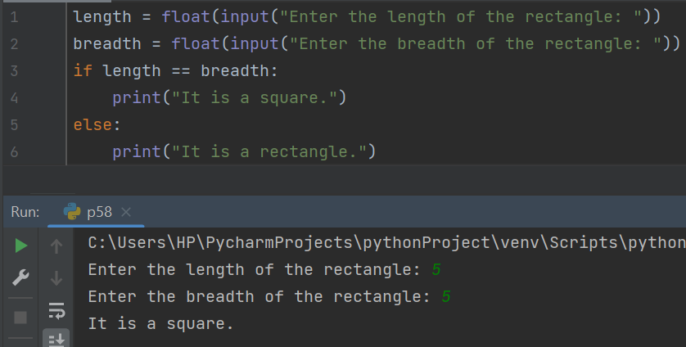

**9. A shop will give discount of 10% if the cost of purchased quantity is more than 1000.**

**Ask user for quantity**

**Suppose, one unit will cost 100.**

**Judge and print total cost for user.**



10. A company decided to give bonus of 5% to employee if his/her year of service is more than 5 years.

Ask user for their salary and year of service and print the net bonus amount.

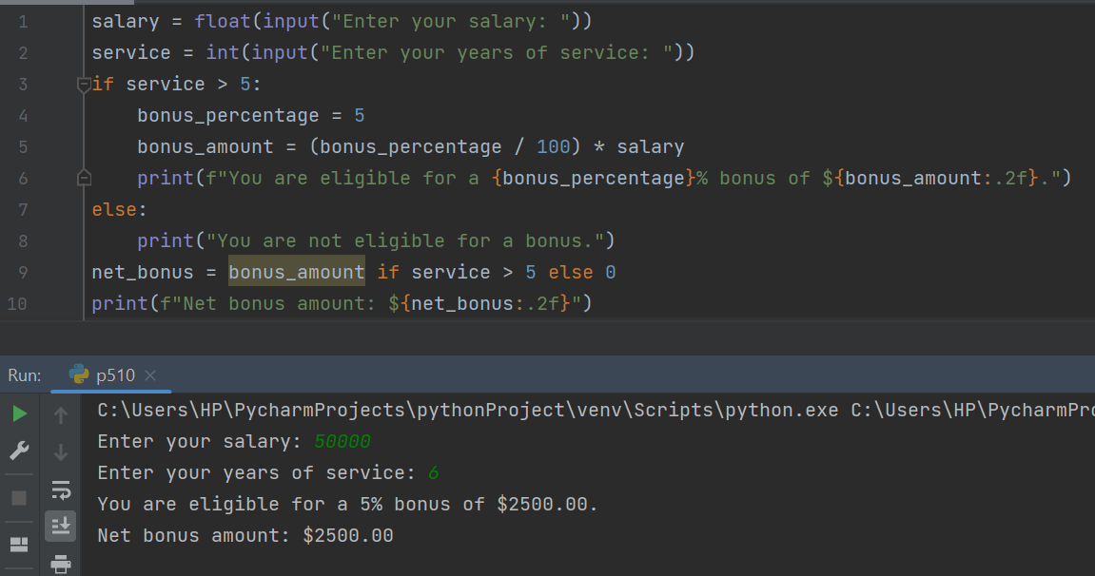

11. A school has following rules for grading system:

a. Below 25 - F

b. 25 to 45 - E

c. 45 to 50 - D

d. 50 to 60 - C

e. 60 to 80 - B

f. Above 80 - A

Ask user to enter marks and print the corresponding grade.

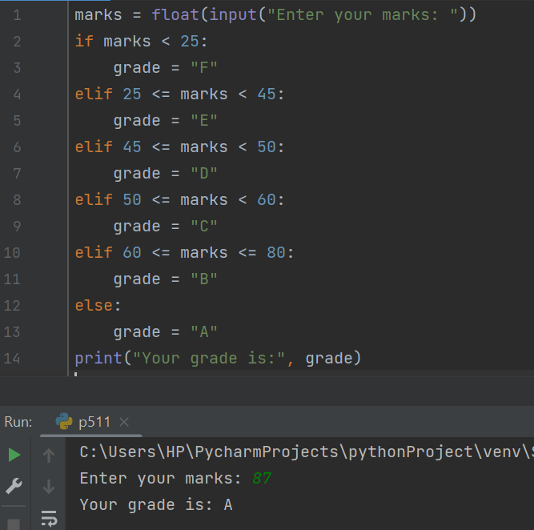

12. A student will not be allowed to sit in exam if his/her attendence is less than 75%.

Take following input from user

Number of classes held

Number of classes attended.

And print

percentage of class attended

Is student is allowed to sit in exam or not.

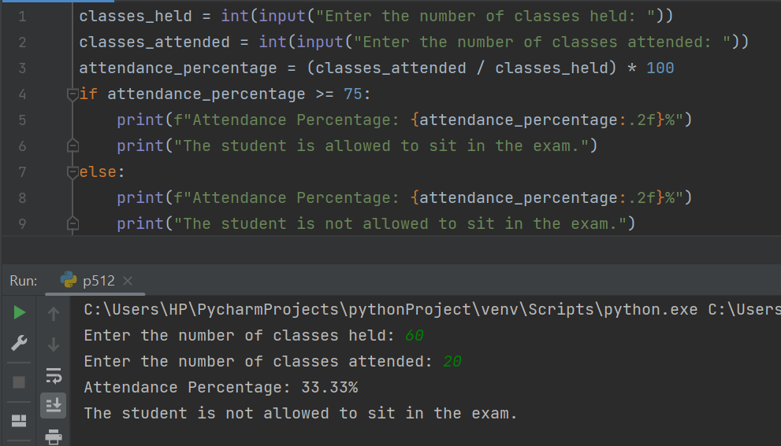

13. Take 10 integers from keyboard using loop and print their average value on the screen.

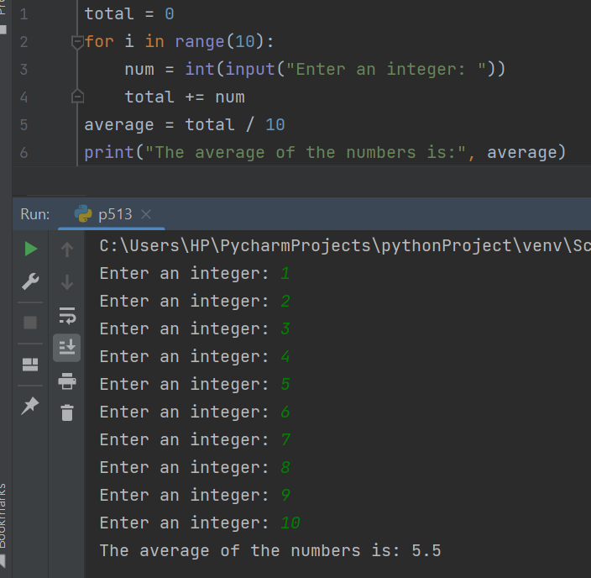

14. Print multiplication table of 24, 50 and 29 using loop.

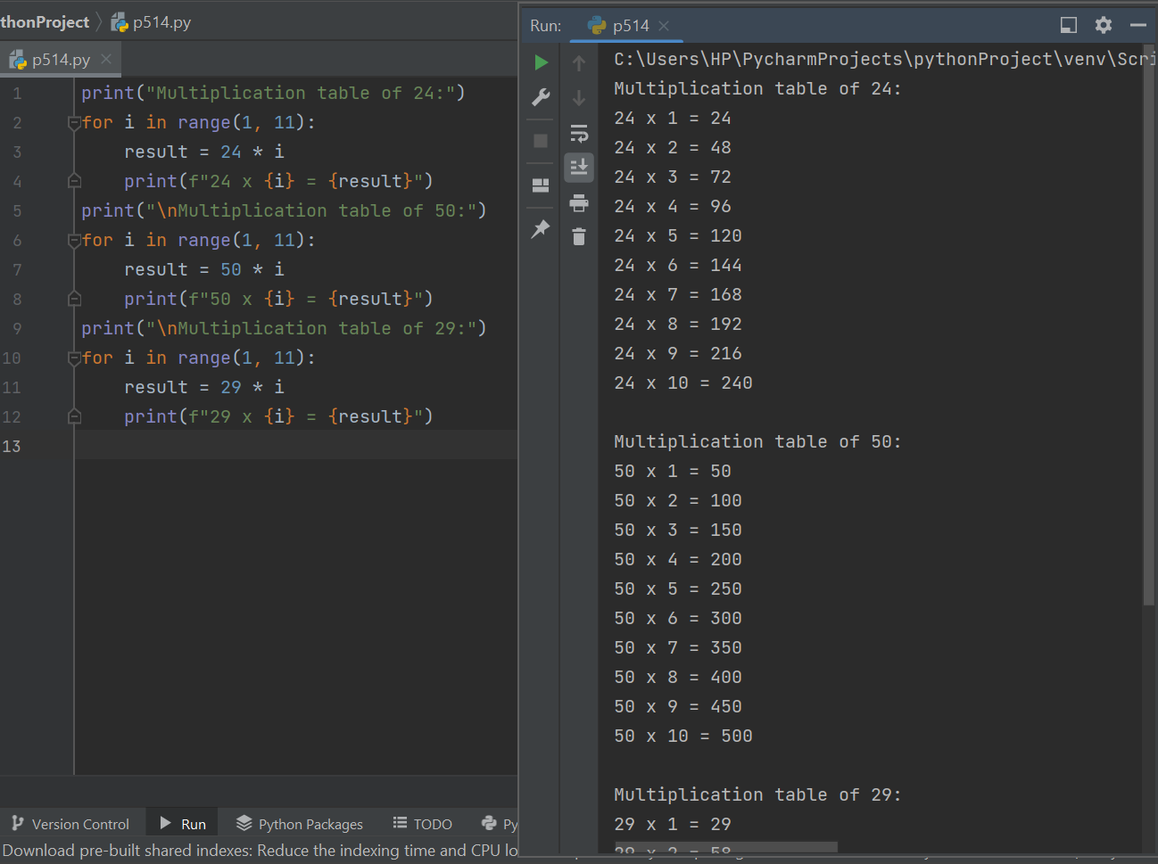

15. Take integer inputs from user until he/she presses q ( Ask to press q to quit after every integer input ). Print average and product of all numbers.

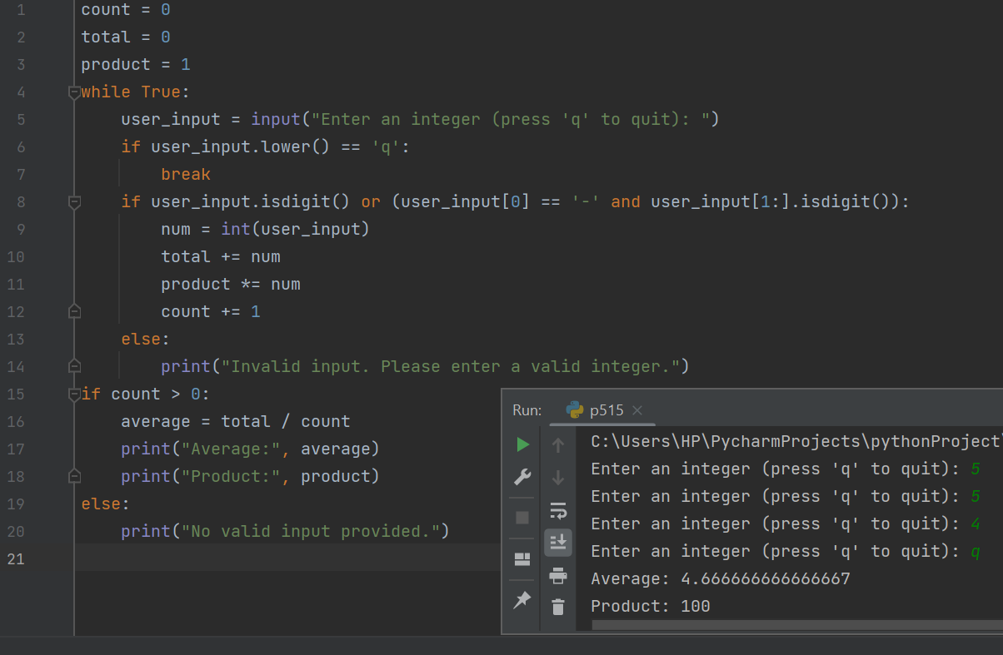

16. Take inputs from user to make a list. Again take one input from user and search it in the list and delete that element, if found. Iterate over list using for loop.

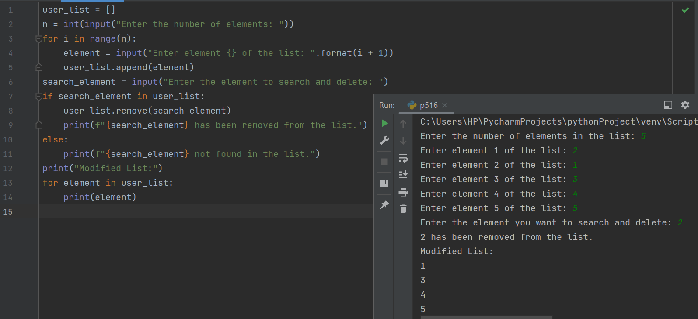

17. Using **range(1,101)**, make three list,

1. one containing all even numbers
2. one containing all odd numbers
3. One containing only prime numbers..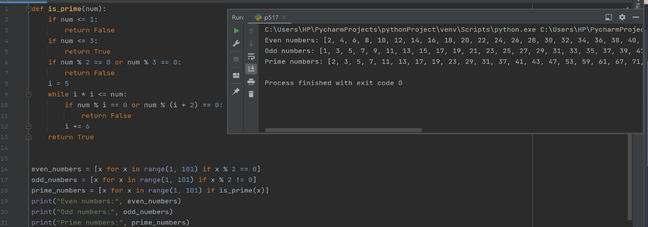

18. From the two list obtained in previous question, make new lists, containing only numbers which are divisible by 4, 6, 8, 10, 3, 5, 7 and 9 in separate lists.

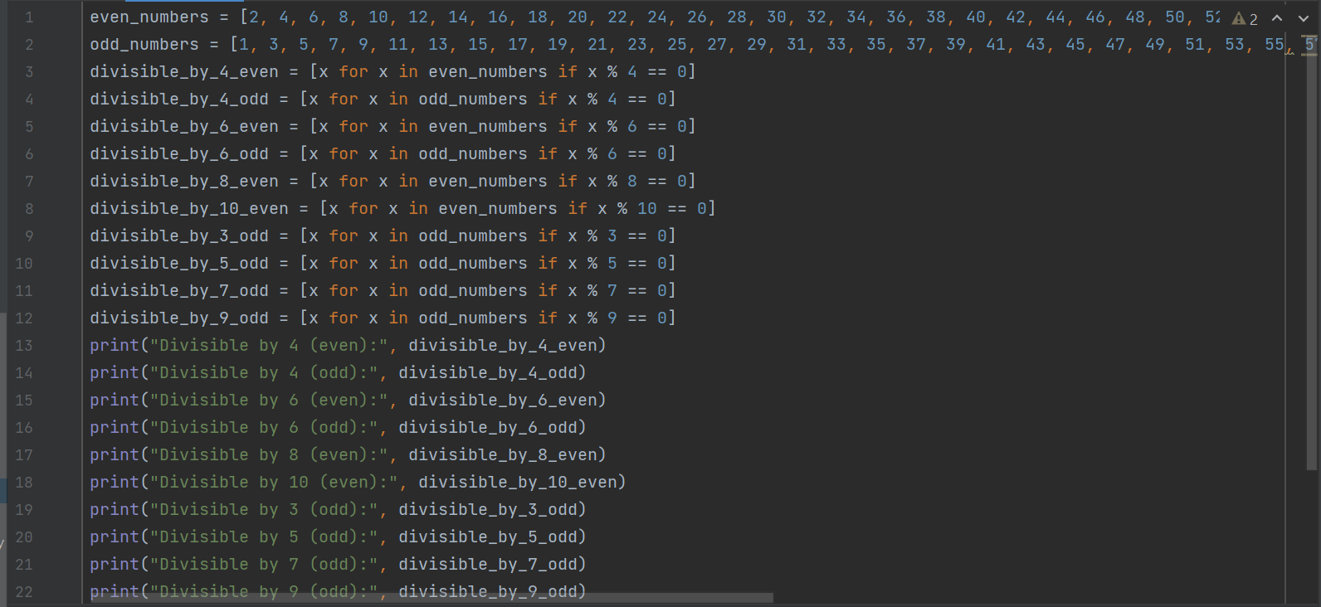

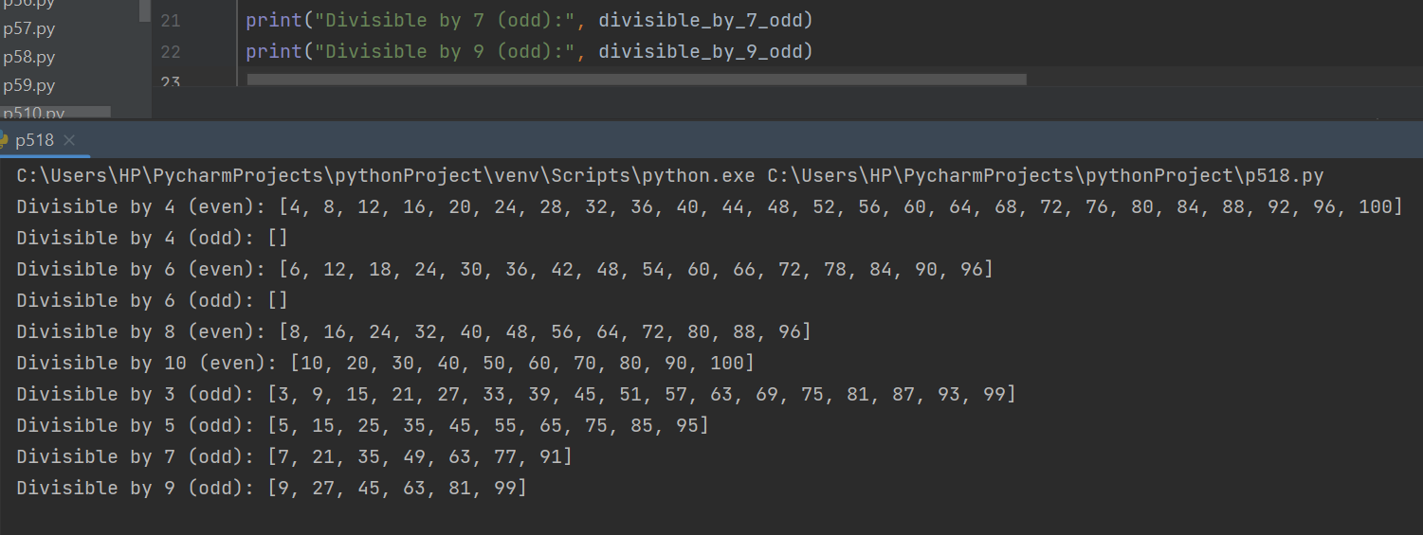

19. From a list containing ints, strings and floats, make three lists to store them separately

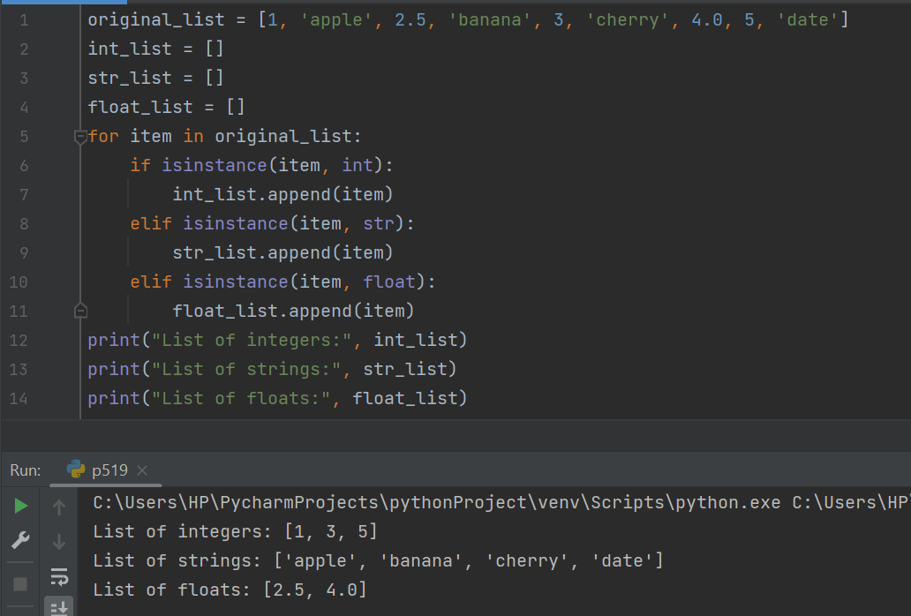

20.You are given with a list of integer elements. Make a new list which will store square of elements of previous list.

